https://www.jdoodle.com/embed/v0/5Wtd
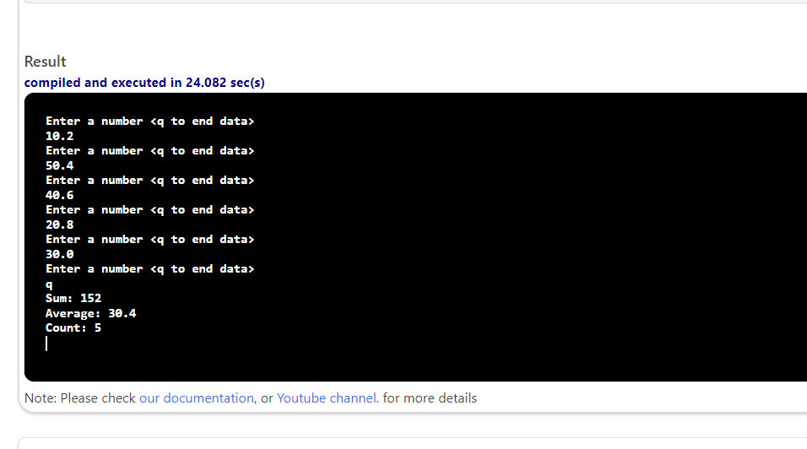

#include <iostream>

using namespace std;

int main()
{
double num;
double sum = 0;
double average;
int numCount = 0;
cout << "Enter a number <q to end data>" << endl;
while (cin >> num)
{
numCount = numCount + 1;
cout << "Enter a number <q to end data>" << endl;
sum += num;
average = sum / numCount;
}
cout<<endl;
cout << "Sum: " << sum << endl;
cout << "Average: " << average << endl;
cout << "Count: " << numCount << endl;
return 0;
}

